ECM Service setup Server 2008

Open administrative tools.

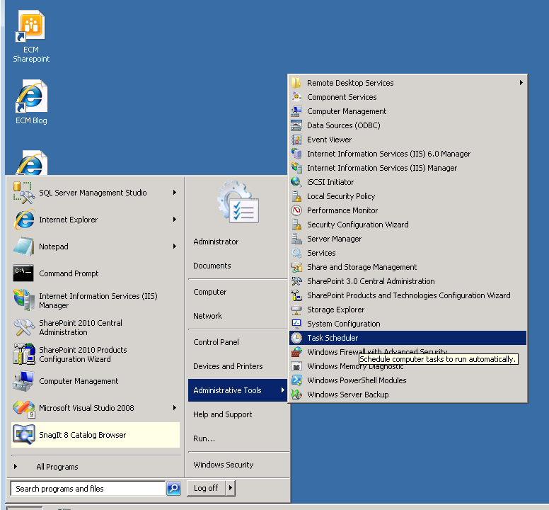

Select the task scheduler.

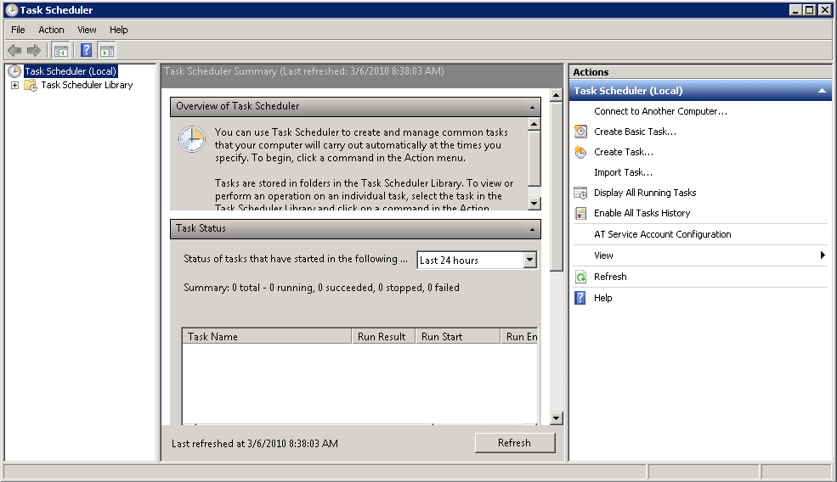

Double click “task scheduler local”.

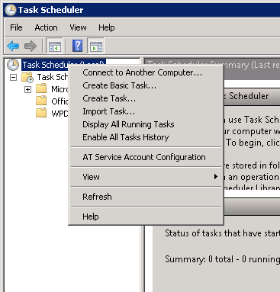

Select #3, create task.

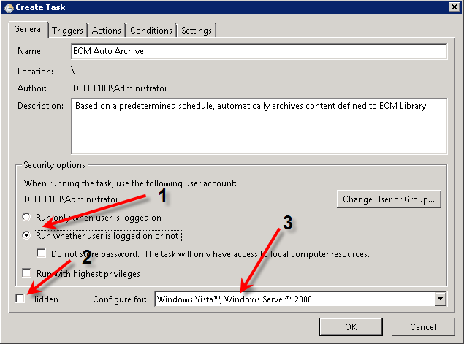

1. Select to run whether logged on or not
2. Select whether to run hidden of not
3. Select execution configuration
4. At the top, fill in the name
5. If desired, fill in a description

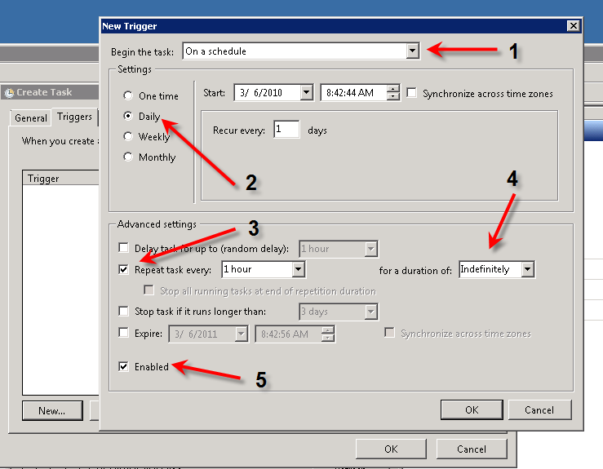

1. Select to run on a schedule
2. Select the frequency (daily / hourly or whatever is desired.)
3. Select the repeat frequency
4. Select the duration for indefinite
5. Enable the task

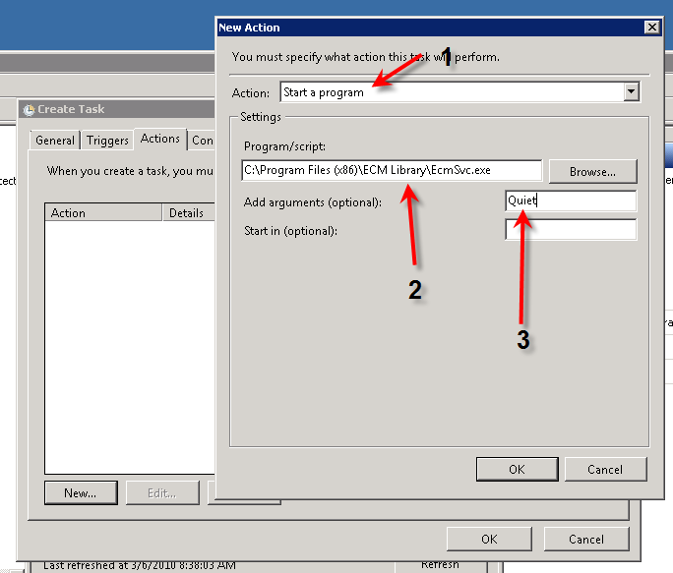

1. In the Actions tab, select action to start the program
2. Select ECM Service
3. Fill in the desired execution mode

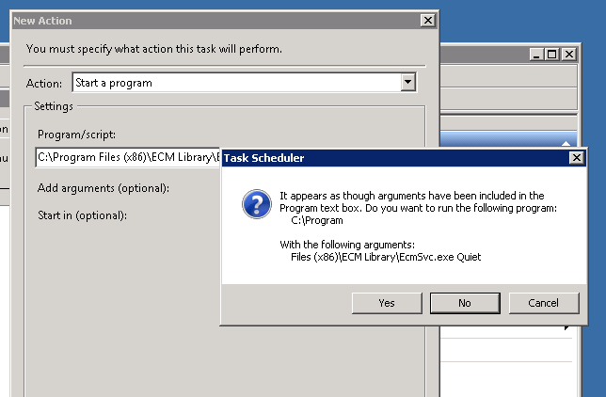

1. When prompted, say yes to allow the execution mode to be passed into ECM Auto-archive Service.

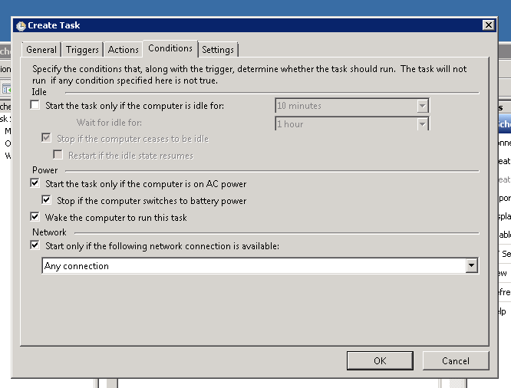

1. Fill in the Conditions tab

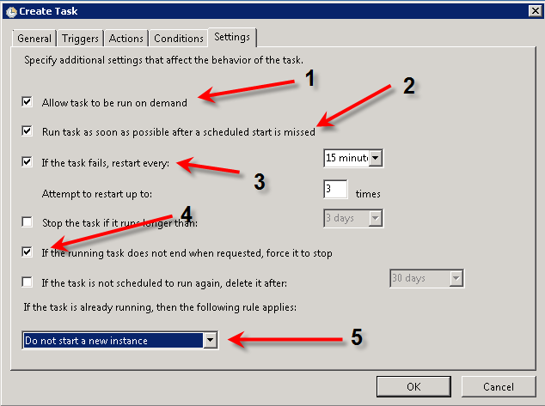

1. Fill in the settings tab – allow to run on demand
2. Run if missed
3. Restart if needed
4. If requested, force a shutdown of the task
5. ***Important*** – do not start a new instance if the task is already running.

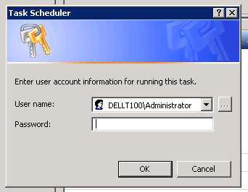

1. Provide the execution credentials



1. This APP can be executed from the command line as shown above.

# The Monitor

